BEGINNING OF TERM ONE EXAMINATION 2024
PRIMARY ONE
ENGLISH

Time allowed: 2hour 15 minutes

My name is ________________________________________________
Class ______________________________________________________

1. Listen and write
(a) ______________ (b) ___________ (c) ____________
(d) ________________________________________________

2. Name these pictures

________________ _________________ _____________

3. Read and draw
(a) The book is here. (b) A cat has an apple.

(c) Daddy is in the car. (d) This is a flower.

4. Write the sentences using “Here is the……………”
(a) Here is the pencil.
(b)  __________________________________________

(c) ___________________________________________

(d) ___________________________________________
(e)  _________________________________________

5. Use in , on and over
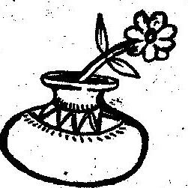
- The flower is ____________ the pot.

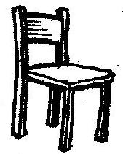

(b) The ball is ____________ the chair.
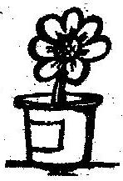


- The pencil is ____________ the water.

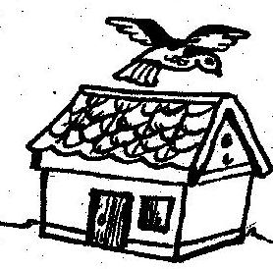
(d) The bird is ___________ the house.

6. Find the missing letters

ch ___ ir toy __ar

b__y t__ee

7. Complete the sentences.
(a) The girl has a _________________.
(b) Mummy can sleep on the _______________.
(c) The fat cat is in the ______________.
(d) They have a big ______________.
(e) Tom can sit on a ______________.

8. Write the correct word for the pictures.
On Monday, the _____________ will go to the
____________. She will sit on the _________.
She will have some ________ and a  ________.
Goodluck

